The formula of thiol is
A. R-O-R
B. R-CO-R
C. R-SH
D. R-OH
ANSWER: C
Ether is an inert solvent and it does not react with:
A. $NH_{3}$
B. Dilute acids
C. Alkalis
D. All of these
ANSWER: D
Diethyl ether on heating with concentrated $HI$ gives two moles of:
A. Iodoform
B. Iodine
C. Ethyl iodide
D. Phenol
ANSWER: C
____________ is an example of oxonium ion
A. ${ H}_{3}O^{+}$
B.
$$R$$
$$R-O^{+}-R$$
C.
$$H$$
$$R-O^{+}-H$$
D. All of these
ANSWER: D

When Sodium ethoxide reacts with bromoethane it leads to the formation of:
A. Ethanol
B. Methoxy ethane
C. Ethoxy ethane
D. Methoxy propane
ANSWER: C
Diethyl ether is prepared by treating ethyl chloride with:
A. $Ag_{2}O$
B. $H_{2}SO_{4}$
C. $Na metal$
D. All of these
ANSWER: A
Complete the following equation:
$2C_{2}H_{5}OH+H_{2}SO_{4}→$ _____________
A. $C_{2}H_{5}-O-CH_{3}$
B. $C_{2}H_{5}-O-C_{2}H_{5}$
C. $CH_{3}-CH-O-C_{2}H_{5}$
D. $CH_{3}-O-C_{2}H_{5}$
ANSWER: B
Common naming of $CH_{3}-O-C_{2}H_{5}$ is:
A. Methoxy ethane
B. Methyl ethyl ether
C. Ethyl methyl ether
D. Ethoxy methane

ANSWER: C

IUPAC name of the following compound is:
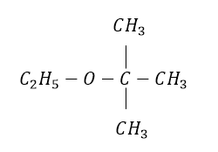
A. Ethyl ter-butyl ether
B. 2-methyl-2-ethoxypropane
C. Ter-butyl methyl ether
D. Iso-butyl ethyl ether
ANSWER: B
Common name of the following compound is:
$$CH_{3}-O-CH_{3}$$
A. Dimethyl ether
B. Methoxy methane
C. 1, 2-methyl ether
D. Ethyl ether
ANSWER: A
IUPAC name of the following compound is:
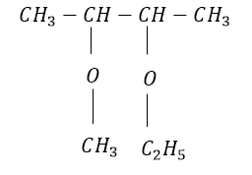
A. 2-methoxy-3-ethoxy butane
B. 2-ethoxy-3-methoxy butane
C. 3-ethoxy-2-methoxy butane
D. 3-methoxy-2-ethoxy butane
ANSWER: C
IUPAC name of the following compound is:
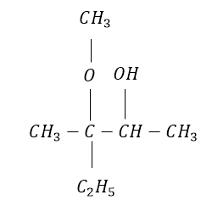
A. 3-ethyl-3-methoxy-2-butanol
B. 2-ethyl-2-methoxy-3-butanol
C. 2-methoxy-2-ethyl-3-butanol
D. 3-methoxy-3-ethyl-2-butanol
ANSWER: A
The formula of ether is
A. R-O-R
B. R-CO-R
C. R-COO-R
D. R-CHO
ANSWER: A
Choose the correct statement from the following:
A. Ethers and alcohols both are regarded as alkyl oxides
B. Ethers and alcohols have the same general formula i.e $C_{n}H_{2n+2}O$
C. Ethers and alcohols are functional group isomers of each other
D. All of these
ANSWER: C
Which of the following compound is an example of unsymmetrical ether?
A. $CH_{3}-O-CH_{3}$
B. $C_{2}H_{5}-O-C_{2}H_{5}$
C. $C_{2}H_{5}-O-CH_{3}$
D. $C_{3}H_{7}-O-C_{3}H_{7}$
ANSWER: C

